PIZZA SALES SQL QUERIES
A.KPIs
1.Total Revenue
SELECT SUM(total_price) AS Total_Revenue from pizza_sales;
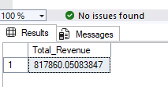
2.Average Order Value
SELECT SUM(total_price) / COUNT(DISTINCT order_id) AS Average_Order_value from pizza_sales;
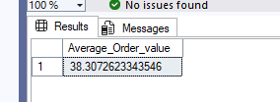
3.Total Pizza Sold
SELECT SUM(quantity) AS Total_Pizza_Sold from pizza_sales;
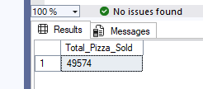
4.Total Orders
SELECT COUNT(DISTINCT order_id) AS Total_orders from pizza_sales;
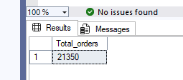

5.Average pizza per order
SELECT CAST(CAST(SUM(quantity) AS decimal(10,2)) /
CAST(COUNT(DISTINCT order_id) AS DECIMAL(10,2)) AS DECIMAL(10,2)) AS Avg_Pizza_Per_order from pizza_sales;
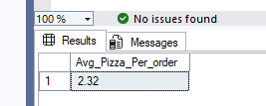
B. Daily Trend for Total Orders
select DATENAME(DW,order_date) AS Order_day,COUNT(DISTINCT order_id)AS Total_orders from pizza_sales
GROUP BY DATENAME(DW,order_date)
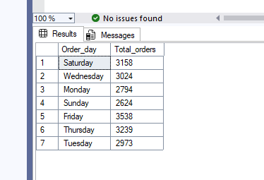
C.Hourly Trend For Orders
Select DATEPART(HOUR , order_time) AS Order_hours, COUNT(DISTINCT order_id) AS Total_orders from pizza_sales
Group by DATEPART(HOUR , order_time)
ORDER by DATEPART(HOUR , order_time)

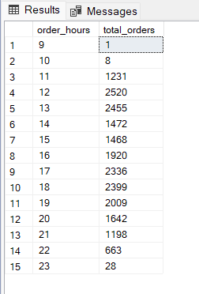
D.% of sales by Pizza Category
SELECT pizza_category, CAST(SUM(total_price) AS DECIMAL(10,2)) as total_revenue,
CAST(SUM(total_price) * 100 / (SELECT SUM(total_price) from pizza_sales) AS DECIMAL(10,2)) AS PCT
FROM pizza_sales
GROUP BY pizza_category

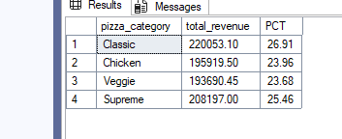
E. % of Sales by Pizza Size
SELECT pizza_size, CAST(SUM(total_price) AS DECIMAL(10,2)) as total_revenue,
CAST(SUM(total_price) * 100 / (SELECT SUM(total_price) from pizza_sales) AS DECIMAL(10,2)) AS PCT
FROM pizza_sales
GROUP BY pizza_size
Order by pizza_size

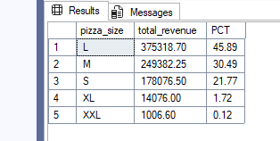
F.Total Pizza sold by Pizza Category
SELECT pizza_category, SUM(quantity) as Total_Quantity_Sold
FROM pizza_sales
WHERE MONTH(order_date) = 2
GROUP BY pizza_category
ORDER BY Total_Quantity_Sold DESC
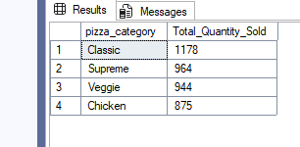
G. Top 5 Best Sellers by Total Pizzas Sold
SELECT Top 5 pizza_name, SUM(quantity) AS Total_Pizza_Sold
FROM pizza_sales
GROUP BY pizza_name
ORDER BY Total_Pizza_Sold DESC
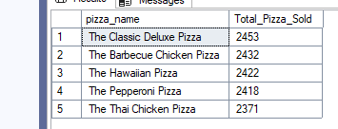
H. Bottom 5 Best Sellers by Total Pizzas Sold
SELECT TOP 5 pizza_name, SUM(quantity) AS Total_Pizza_Sold
FROM pizza_sales
GROUP BY pizza_name
ORDER BY Total_Pizza_Sold ASC
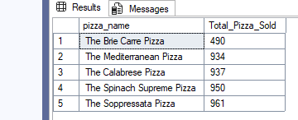
NOTE:
If you want to apply the Month, Quarter, Week filters to the above queries you can use WHERE clause. Follow some of below examples
SELECT DATENAME(DW, order_date) AS order_day, COUNT(DISTINCT order_id) AS total_orders
FROM pizza_sales
WHERE MONTH(order_date) = 1
GROUP BY DATENAME(DW, order_date)

*Here MONTH(order_date) = 1 indicates that the output is for the month of January. MONTH(order_date) = 4 indicates output for Month of April.

SELECT DATENAME(DW, order_date) AS order_day, COUNT(DISTINCT order_id) AS total_orders
FROM pizza_sales
WHERE DATEPART(QUARTER, order_date) = 1
GROUP BY DATENAME(DW, order_date)

*Here DATEPART(QUARTER, order_date) = 1 indicates that the output is for the Quarter 1. MONTH(order_date) = 3 indicates output for Quarter 3.

